

SIMATS ENGINEERING

Saveetha Institute of Medical and Technical Sciences
Chennai- 602105

Student Name: G.Vinay Reg.No.:192312380
Course Code: CSA 0211 Slot: B
Course Name: C-PROGRAMING
Course Faculty: Dr. K. S. SARAVANAN
Project Title: Smart University Laboratory Equipment Monitoring and Allocation System using C
Module Photographs: (3 photographs –Module Photo, Individual student contribution module work in the project and presentation image)
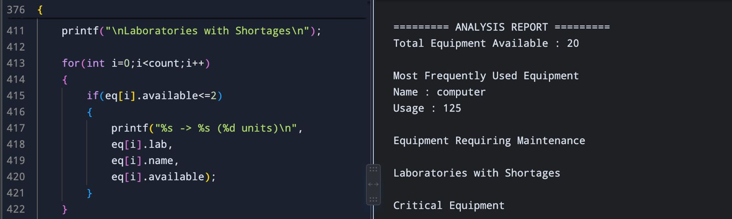
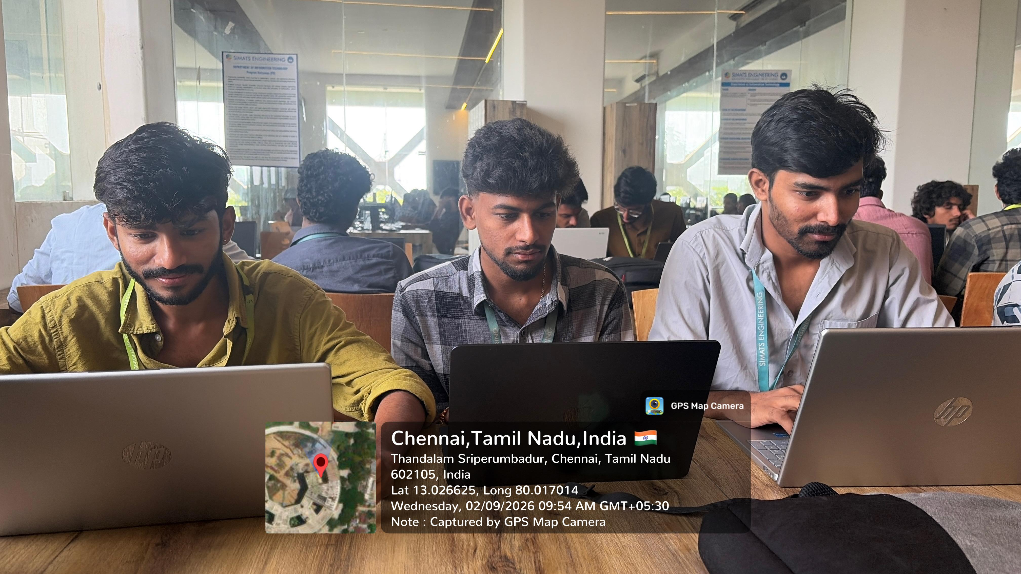
Project Description: (here you write what you did in this project (contribution) including Model Description
The Smart University Laboratory Equipment Monitoring and Allocation System is a C-based application designed to improve the management of laboratory resources in universities. It helps administrators maintain accurate records of equipment such as computers, sensors, routers, projectors, and electronic kits. The system supports equipment registration, updating, searching, sorting, allocation, and maintenance monitoring through a menu-driven interface. It uses arrays and strings to store equipment details efficiently and applies functions, recursion, pointers, and file handling for modular and reliable implementation. The application also prevents duplicate equipment IDs and permanently stores inventory data using files. Equipment is classified based on availability and maintenance status to assist in better decision-making. This project promotes efficient utilization of laboratory resources while reducing manual errors. It supports SDG 4 (Quality Education), SDG 9 (Industry, Innovation and Infrastructure), and SDG 12 (Responsible Consumption and Production). Overall, the system provides a practical and scalable solution for smart laboratory inventory management.

Student Signature Guide Signature

